roid

217, Sheikh Rashid Building

P.O Box 56272, Dubai

United Arab Emirates

Tel: +971 4 2973236 / 04 2974007

Email: uae@verbat.com

PROJECT   
PROPOSAL

**Hyper Local Search Engine**

|  |  |
| --- | --- |
| **Prepared for:**  **Mohammed Kassim** | **Submission Date:**  13 June 2017  **Proposal ID:** AD/BP/13062017/1343/1 |

___________________________________________________________________________________________________________________________________________  
Conﬁdentiality Notice: This Proposal is conﬁdential and contains proprietary information and intellectual property of Verbanet Technologies LLC. Neither this proposal nor any of the information contained herein may be reproduced or disclosed under any circumstances without the express written permission of Verbanet.

© 2017 by Verbanet Technologies LLC. All rights reserved. Confidential.

___________________________________________________________________________________________________________________________________________

Project Contacts

|  |  |
| --- | --- |
| Client Information | |
| Project Name | Educational Management Information System |
| Client Name | Berberra |
| Client Address |  |
| Contact Person |  |
| Contact Person Email |  |
| Contact Person Phone Number |  |
| Verbat Information | |
| Contact Person | Joyce Daniel |
| Contact Person Phone Number | +971 42973236 |
| Contact Person E-Mail | [joyce.daniel@verbat.com](mailto:joyce.daniel@verbat.com) |
| Address | PO Box 56272, Dubai, United Arab Emirates |
| Physical Address | 217, Sheikh Rasheed Building, Hor Al Anz East |
| Project Information | |
| Proposed Technology/Methodology | Ruby Jems 1.3.7, MySQL 5.0, CSS3, HTML 5, Apache, NGINX, Rails 2.3.5, RUBY 1.8.7 |
| Anticipate Start Date | NA |
| Proposal Valid For | 30 Calendar days from the submission of the proposal |

**Table of Content**

1 Scope of Work 6

1.1 Key Platform Stakeholders / “Actors” 7

1.2 Solution Objective 9

1.2.1 Application Basic Modules 10

1.2.2 Advanced Modules 11

1.3 Advantages of Proposed Solution 12

1.4 Why Verbat 13

1.5 Key Differentiators 14

1.6 Technology & Services 15

2 Functional Specification 16

2.1 Phase 1 16

3 High Level Architecture 20

3.1 High Level technical Solution 20

3.2 Application Overview 21

3.3 Basic Application Workflow 22

3.4 Workflows by Functionality 28

3.4.1 Student Management 28

3.4.2 Course and Batch Management 28

3.4.3 Subject Management 29

3.4.4 Examination Management 30

3.4.5 Human Resources Module 31

3.4.6 Time Table Management 32

3.4.7 Finance Management 33

4 Agile Development Mode 36

5 Nonfunctional Requirement (Others) 36

6 Assumptions 36

7 Out of Scope 37

8 Technology Solution 38

8.1 Proposed System Environment 38

8.2 Technical Configurations 39

8.2.1 Development Tools 39

8.2.2 Recommended (minimum) Web Hosting Package 39

8.2.3 Browser Compatibility 39

8.2.4 Hardware Interface 39

9 Commercials 40

9.1 Web Application 40

9.2 Payment Terms 40

9.3 Mode of Payment 40

10 Delivery Management 41

10.1 Project Management 41

10.2 Roles and Responsibilities 41

10.3 Delivery Activity Summary 42

10.4 Project Implementation Plan 42

10.5 Deliverable Artifacts 42

10.6 Application Deliverables 43

10.6.1 Phase 1 Deliverables 43

10.6.2 Phase 2 (Enhancements – i) 44

10.6.3 Phase 3 (Enhancement-ii) 44

10.7 Estimated Delivery Time 45

10.8 Release Planning 45

10.9 Risk and Contingency Planning 45

11 Change Management 46

12 Miscellaneous 48

12.1 Acceptance Criteria 48

12.2 General Terms and Conditions 48

12.3 Assumptions and Dependencies 49

12.4 Source Code & Intellectual Property Rights 49

12.5 Maintenance & Support 50

12.6 Service Level Agreement 51

13 Our Clients 52

# Scope of Work

Save the children, NRC and Care Netherlands as a consortium have been implementing an education program locally known as Horumarinta Elmiga II (HEII) is an education project funded by the European Union.  The scope of the project is to develop an Educational Information Management System (EIMS). The application shall be able to manage the schools (Primary & Secondary), Technical & Vocational Education & Training (TVET) Centers universities & colleges in SIX administrative regions of Somaliland. The application will aid in the planning, monitoring and reporting of the educational system using various role based access to application dashboards.

The key strategic objectives would be to assess the educational system for

1. Gross Enrollment Ratio (GER) / Net Enrollment Ratio (NER) by gender and region (Urban & Rural)
2. Trends in the allocation of national budget to education sector
3. Pupil–Teacher ratio trends across regions, schools, universities etc.
4. Pupil-Textbook ratio
5. Transition rates from one grade to next
6. Retention Rates of students in school
7. Dropout rates of the students disintegrated by grade, gender, urban vs. rural setting etc.
8. Repetition rate of students
9. Repetition rates of students disintegrated by grade, gender, urban vs. rural setting etc.
10. Percentage of teachers using learning center teaching technologies
11. Percentage of students actively engaged in the learning process
12. Percentage of qualified teachers disintegrated by grade, gender, urban vs. rural setting etc.
13. Quality Assurance: percentage of schools that receive a supervisors visit
14. Learning outcomes of the students in the targeted schools

Verbat is pleased to submit the proposal and values it as a great opportunity to have a long term & mutually beneficial association with the client. Verbat has gone through the requirement and presents a proposal for the requested system.

## Key Platform Stakeholders / “Actors”

The application is divided into different modules and each module can be assigned access to different users / actors or to different roles defined in the application. Roles typically represent the key stakeholders of the system. Roles can be either predefined or custom defined. Hence the system shall not put a restrictions on the privileges or entitlements assigned to a role or a user. The roles / actors described are some predefined roles with in the system

1. **Administrators:** This users shall have access to the following modules
   * Admissions
   * Student Details
   * User Management
   * News and events management
   * Examinations
   * Timetable management
   * Attendance management
   * Application wide settings
   * Human Resources
   * Finance
2. **Employees:** Employees may be teachers or allied office staff working for the schools, universities and other technical institutions. They have access to the following modules, but may have access to other modules if they have partial administrative access (e.g. Finance)
   * Profile
   * Campus news
   * Leave of absence
   * Reminders
   * Examinations
   * Human Resources
   * Library
3. **Students:**  Students have access to the following modules
   * Profile
   * Campus news
   * Timetable
   * Reminders
   * Academics
   * Library
4. **School Board Management:**  These users will have access to reports that span across school(s), regions etc. Examples are
   * School Wide Reports
     1. Exam Wise Reports
     2. Subject wise report
     3. Grouped exam reports
     4. Archived student reports
     5. Student Rankings per subject
     6. Student Rankings per batch
     7. Student rankings per course
     8. Student rankings per school
     9. Student rankings per attendance
     10. Ranking level reports
     11. View Transcripts
     12. Combined reports

* Intra school, region wise reports

1. Gross Enrollment Ratio (GER) / Net Enrollment Ratio (NER) by gender and region (Urban & Rural)
2. Trends in the allocation of national budget to education sector
3. Pupil–Teacher ratio trends across regions, schools, universities etc.
4. Pupil-Textbook ratio
5. Transition rates from one grade to next
6. Retention Rates of students in school
7. Dropout rates of the students disintegrated by grade, gender, urban vs. rural setting etc.
8. Repetition rate of students
9. Repetition rates of students disintegrated by grade, gender, urban vs. rural setting etc.
10. Percentage of teachers using learning center teaching technologies
11. Percentage of students actively engaged in the learning process
12. Percentage of qualified teachers disintegrated by grade, gender, urban vs. rural setting etc.
13. Quality Assurance: percentage of schools that receive a supervisors visit
    * + Learning outcomes of the students in the targeted schools
14. **System Admins:** System admins are responsible for managing and maintaining the application. They help with the day to day running of the application as well adding (integrating) new instances of schools, universities to the system. They shall also be responsible for integrating third party plugins as well as updating the system.

**Stand-Alone Fixed Bid**

Verbat will be following a stand–alone fixed bid solution delivery model wherein the required solution would be devised and a suitable pricing would be offered.

## Solution Objective

VERBAT’s EDMI System shall provide user-friendly dashboards with login access for teachers, non-teaching staff, students, parents and management personnel. The various modules shall facilitate all the processes for an institution, from admission of new students to generating transfer certificates when students complete their studies.

The EDMI system will have modules to manage Timetable, Attendance, Examinations, Gradebooks, Campus News, Hostel, Library, Transportation, School Calendar, Events and many more. It shall have a fully-fledged Human Resource module to manage the payroll and employee pay slips. The Finance module has provision to plan and allot different fee structures to students.

Additionally the EDMI system will facilitate the management of a Group of Institutions, such as universities. Schools and universities can be enrolled. With each institution acting as a node of a tree structure. Entire groups can be accessed from super-admin dashboard.

A plugin system allows instances of an institution to access various plugins assigned by admin. It simplifies the various operations and processes of the institutes, such as Library plugin will handle the library operations and processes, the Hostel plugin manages the hostel fees, room allocations etc.

### Application Basic Modules

#### Courses and Batches

Application can be configured to manage multiple courses and batches depending on the institutions systems and process

#### Human Resources

The system shall record and organize all employee details and enable quick access to employee details like payroll and leaves

#### Student Attendance

Attendance can be marked and tracked quickly by teachers so that they can focus on the class

#### Timetable

System will allow the creation of error free time tables that allows for the best utilization of teachers and other essential staff

#### Examinations

Different types of grading systems can be configured to generate various student examination reports. Examinations can be scheduled and managed to fit the needs of the institutions

#### Custom Dashboards

Custom dashboards can be created using ‘portlets’. These portlets can be assigned by the admin or selected by the user. Other features of the dashboard include searchable content

#### Student Admission

Admissions can be managed using customizable forms, be it a university or a primary school admission

#### News and events

Disseminate news and event information to a school, college, or institution wide

#### User Management

User roles such as student, teacher, parent, and administrator can be created. Roles can be tweaked to manage privileges

#### Finance

Finance module shall be used to record financial transactions, automate transactions and generate financial reports

#### Student Information

Information on students can be searched (Both current and archived) and their student records can be retrieved

#### Login

Students, parents, employees and teachers shall have separate login credentials along with unique privileges

#### Report center

A reporting module / dashboard shall provide various reports on students, courses, attendance, institutions etc.

### Advanced Modules

#### Assignment

Assignments shall be distributed to students with defined due dates, notes and grades

#### Hostels

Hostel module shall provide features to manage all the hostels and residential facilities in the institutions. Features include room allocation, fee collection, reports for hostel administration activities

#### Transport

This module automates the transportation administration like route optimization, vehicle management, route management, route assignment, transportation fees etc.

#### Inventory

Manage institution’s inventor, including optimized or efficient utilization. This module shall also manage suppliers, items in inventory, costs, raise indents, purchase orders, raise invoices and goods received notes

#### Placement

This module shall provide functionality to streamline campus recruitment process

#### Discipline

Module that shall record and track disciplinary incidents to hold students responsible for their actions

#### Applicant registration

Module that shall allow students to register for courses online

#### Custom Import & Export

A feature to import and export data in bulk. This feature shall be useful when more than one instance of an entity needs to be added to the system, or when reports need to be exported or when data needs to be exported to a third party application.

Verbat’s Solution architects have conducted a thorough research on the requirements and have come to the conclusion that our proposed solution, which is detailed further in this document, will meet the requirements put forth by the client. And the proposed solution will be delivered in a phased approach as per Verbat’s stand-alone fixed bid solution model.

**Strong and Scalable platform:** The platform proposed will be strong and scalable enough to accommodate future enhancements.

**Accelerated solution:** The framework would act as a solution accelerator. It would provide the basic building blocks which could be reused in future for building new components and features.

**High performance:** The light weight framework used consumes fewer system resources thereby making the application perform faster.

**Security:** The application will be developed considering various aspects of security.

## Advantages of Proposed Solution



01

Agile development offering reliable, secure solution

02

Smooth transition and quicker completion of processes

03

User friendly interfaces enabling easy navigation between screens

## Why Verbat

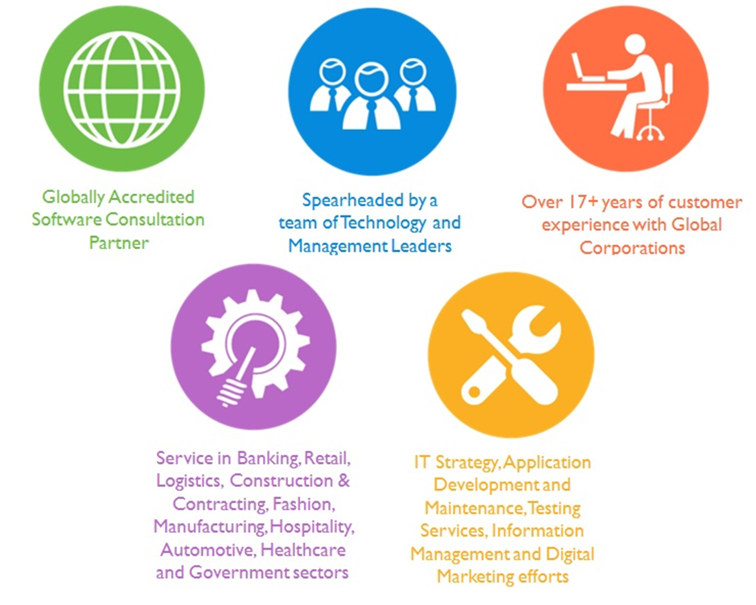

## Key Differentiators

Delivered digital transformation expertise to global customers for over a decade by following industry best practices to maximize ROI for client

Keen technology intelligence combined with aggressive market research to deliver solutions that achieve results with measurable value

Enable access to global consulting expertise with strong local market and business knowledge

Commercial Model that is customizable for your business needs

Services that are designed to optimize applications for improved performance and overall efficiency

1,000,000 plus man-hours of expertise in technology frameworks spanning Microsoft, Open Source, mobility platforms and other proprietary IT technology

Partners top technology vendors to bring in the latest and best services in integration, collaboration, and development

Commercial Model that is customizable for your business needs

Proven Methodologies & Processes

Investment in R & D

Strong Local Presence

Flexible commercial Models

Technology Associations

Software Development Experience

Offshore Development Centre

Quality Assurance & Testing

## Technology & Services



Technology  
&  
Services

Cloud/Traditional Hosting

User Interface & Design

Digital Marketing

Mobility Solutions

Testing Services

Application  
Development

# Functional Specification

## Phase 1

|  |
| --- |
| **Course and Batch management** |
| Manage Course (Add, Edit, Delete, View) |
| Manage Batch |
| Select Course |
| View Batch List -> Select Batch |
| View Student List -> View Student Profile |
| View Batch Exams |
| Create Exams, Connect Exam |
| Edit batch |
| Manage Batch (add subjects & electives, assign tutors) |
| Batch Transfer for graduation |
| **Subject Management** |
| Manage Subjects (Add, Edit, del, view) |
| Manage Elective groups |
| Add subjects to electives |
| Assign students |
| **Examination Management** |
| Set Grading Levels |
| Create Exam |
| Publish Exam |
| Enter marks |
| Publish Results |
| Connect Exams |
| Generate Reports |
| Ranking Levels |
| Class Designations |
| CCE Settings (Continuous & Comprehensive Evaluation) |
| Basic Settings, Scholastic Settings, Co-scholastic settings |
| **Human Resources** |
| Manage Employee |
| Grade, category, position, department |
| Add Employee bank |
| Add Payroll category |
| Employee Search, View profile |
| Employee Admission/ subject Allocation |
| Employee attendance , Leave types |
| Attendance Register |
| Create Pay slip & employee slip |
| Employee Admission |
| Basic details, Address details, Bank , Additional Details, Assign roles |
| **Time Table Management** |
| Create Timetable |
| Set Class timings & week days |
| Set Time period, Start and end date, Assign hours |
| Work Allotment (Assign subjects to teachers) |
| Create / Edit timetable structure |
| Teacher Timetable |
| Institution Time Table (entire timetable for a day) |
| View Timetables |
| Create Week Days |
| **Finance Management** |
| Create Fees |
| Create Master fee category |
| Particular for master fee |
| Fee Discounts |
| Fee Collection |
| Fee Defaulters |
| Fee Submission |
| Create Fee Structure |
| Manage Donations |
| Asset & Liability Management (Create, delete, edit, view) |
| Pay slip Management |
| Manage Category |
| Auto Transactions |
| manual Transactions |
| Transactions : Add Expense /Income |
| Reports |
| **Dashboards** |
| **Admin Dashboard** |
| Admission |
| Student Details |
| Manage Users |
| Manage News |
| Manage Exams |
| Manage Timetable |
| Manage Attendance |
| Application Settings |
| Dashboard Settings |
| Human Resources |
| Finance |
| **Employee Dashboard** |
| My Profile |
| News |
| leaves |
| Reminders |
| Examinations |
| Human Resources |
| Library |
| **Student Dashboard** |
| My Profile |
| campus News |
| Timetable |
| Reminders |
| Academics |
| Library |
| **Exam Dashboard** |
| Exam Settings (Grading levels, Ranking levels, class designations etc.) |
| Exam Management (Create exams, enter results, Connect Exams etc.) |
| Generate Reports |
| reports center |
| **Messaging System** |
| Inbox |
| Compose message |
| Create Reminders |
| **Leave Management** |
| Apply for leave |
| Leave approval |
| Leave status |
| My Leaves |
| **Calendar & Events** |
| Create Events |
| Calendar view |
| **Pay slip Management** |
| Pay slip generator |
| Pay slip Reverser |
| Pay slip Approval |
| Department Wise Pay slip |
| Personal Pay slip |
| Reject Pay slip |
| **Analytics and Reports** |
| Exam Wise Reports |
| Subject wise report |
| Grouped exam reports |
| Archived student reports |
| Student Rankings per subject |
| Student Rankings per batch |
| Student rankings per course |
| Student rankings per school |
| Student rankings per attendance |
| Ranking level reports |
| View Transcripts |
| Combined reports |
| **Exam Workflow** |
| Configure general settings (School info, Attendance, Financial yr etc.) |
| Add course, subject with credit hours |
| GPA/CGPA,/CWA calculation algorithm |

# High Level Architecture

## High Level technical Solution

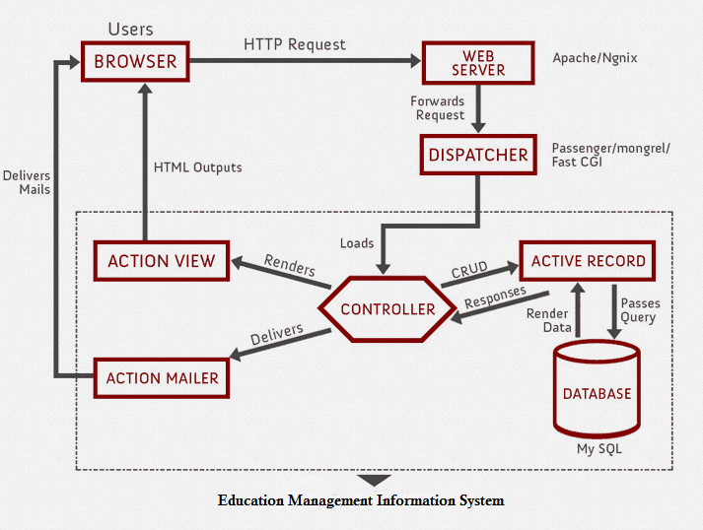

## Application Overview

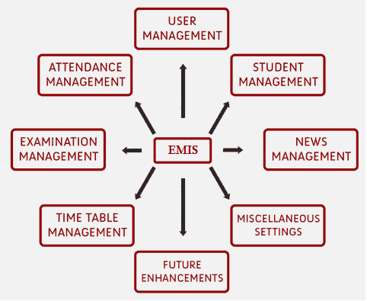

## Basic Application Workflow

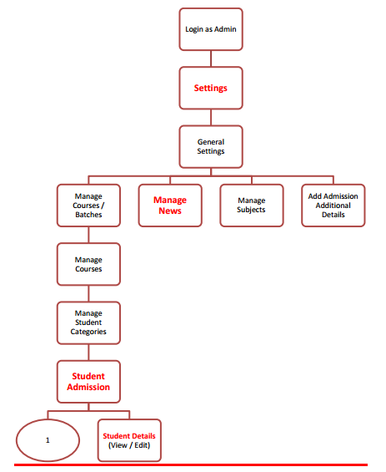

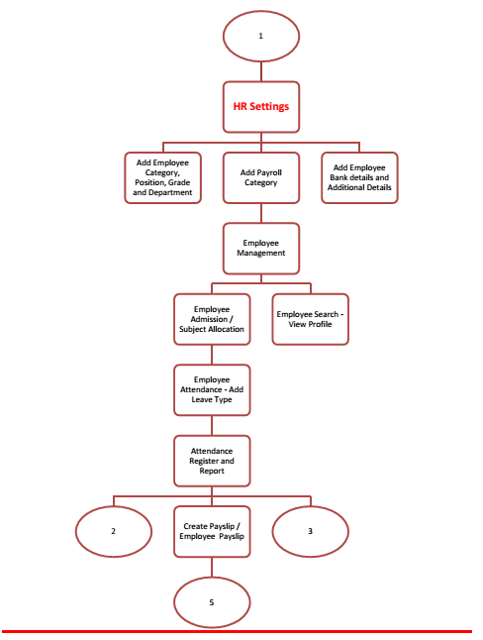

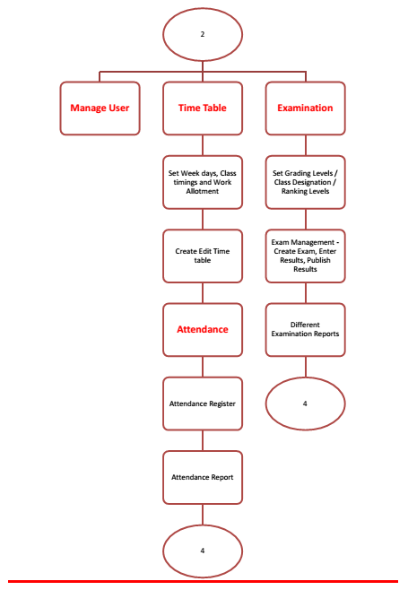

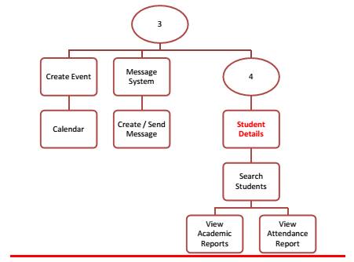

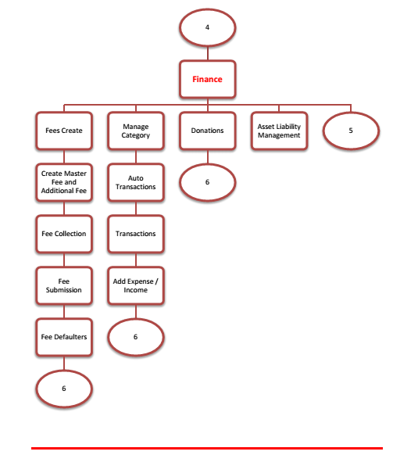

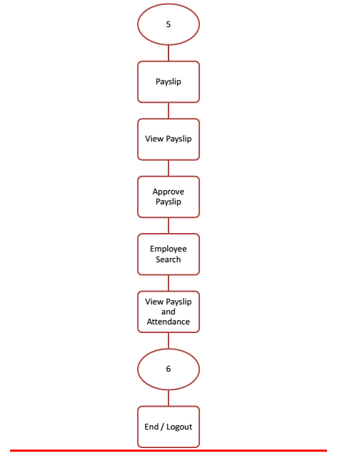

## Workflows by Functionality

### Student Management

### Course and Batch Management

### Subject Management

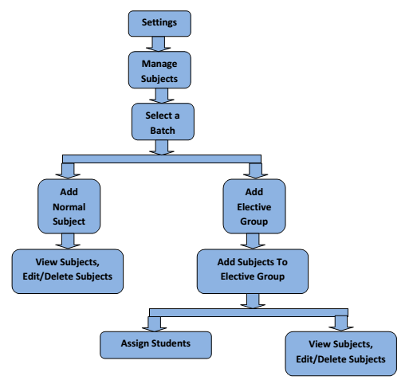

### Examination Management

### Human Resources Module

### Time Table Management

### Finance Management

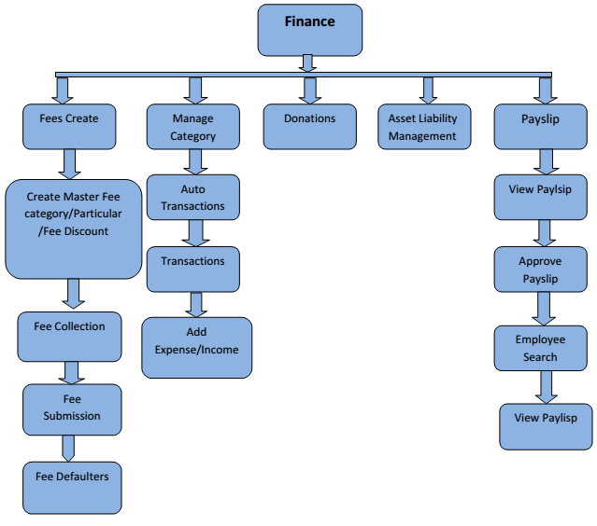Sample Dashboard Views

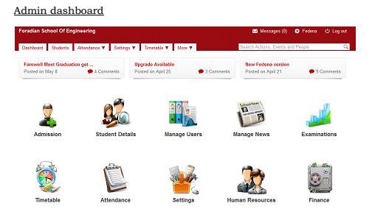

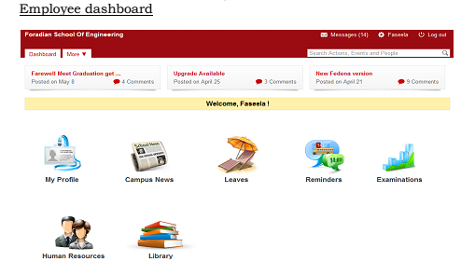

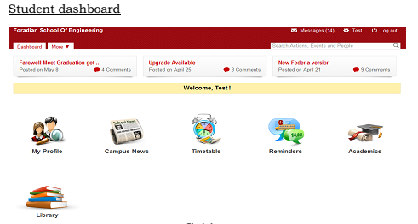

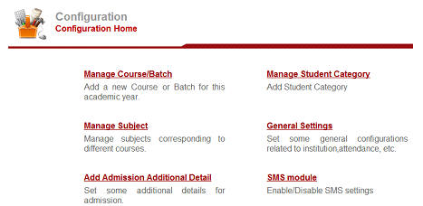

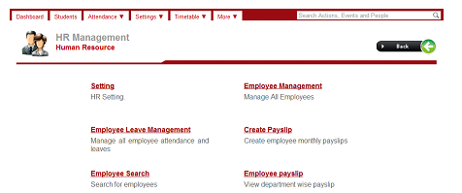

# Agile Development Mode

Verbat Practices distributed Agile development methodology, because we realize that communication between geographically distributed teams becomes cumbersome if the project is not supplemented by ancillary documents such as project plan, SRS, wireframes, prototypes etc. Based on past experience, our clients have appreciated the prospect of knowing upfront what is being built at a reasonably high level of detail, while still having the flexibility to mediate change in requirements or priorities.

While this is our general approach, Verbat can adapt and comply with development standards that are agreeable to the client.

# Nonfunctional Requirement (Others)

|  |  |
| --- | --- |
| **Requirement** | **Details** |
| User Experience and  UI Design | * The application will be developed only in English * The layout and graphical components will be created considering the usability factors |
| Performance | * Application will allow users to have smooth and quick access to the information or services they require. |
| Security | * The system will be protected against attempts of security breaching that may arise. * Web security standards will be followed. |

# Assumptions

The project solution and technology is created from the initial understanding of the requirement shared with Verbat through mails and meetings. The proposed solution is based on the following assumptions:

* Client to provide Verbat with the branding guidelines.
* The proposed application will be in English
* Client will purchase the necessary templates needed for development
* Client shall provide licensed images and logos in specified size & format
* Requirements should be well defined, agreed and signed-off by the client
* Internet connectivity is required for the functioning of the web application.
* Customer will procure templates, SSL certificates & Payment processor
* Client will procure SMS gateways
* Testing will be done in latest versions of Google Chrome, Mozilla, Safari, & Edge web browsers only
* Development Contingent upon timely feedback from client
* Client will procure Google services
* Client will procure Azure integration if needed

# Out of Scope

Following are considered to be out of scope while creating this proposal.

* Purchase of images, fonts
* Adding new features to the application other than mentioned in the functional specification.
* Any language other than English
* Manual data entry
* Hardware Integrations / procurement and purchase
* Database migration
* Content writing
* Content or image procurement or uploading or editing.
* Hosting Infrastructure and Maintenance
* Annual Maintenance of the application (Bug fixing, debugging) - For AMC details, please refer section titled “Maintenance and Support”
* Physical deployment at client’s site
* Backup solution and Disaster recovery

# Technology Solution

## Proposed System Environment



**HTML / CSS3**

**/ JQuery**

**MySQL, NGINX, APACHE,**

**RubyOn Rails, JavaScript, Eclipse**

**MS SQL2012  
Windows 8/10  
Web Services**

## Technical Configurations

### Development Tools

* RubyOnRails, Eclipse
* MySQL, NGINX
* HTML / CSS 3
* Ajax, JavaScript, JQuery

### Recommended (minimum) Web Hosting Package

* OctaCore CPU
* RAM: 32 GB
* MongoDB Enterprise Advanced
* Disk Space: 1 TB
* Monthly Bandwidth: 20 TB
* Web site Server Software – Apache

### Browser Compatibility

* Chrome version: 56
* Firefox version: 51
* Edge version: 39
* Safari version 10.1

### Hardware Interface

**Desktop**

The application is reliant on hardware interfaces to provide a seamless automated user experience.

* Computer with Windows 8 or 10 OS
* Compatible Browsers as specified in section 7.2.3

# Commercials

## Web Application

|  |  |  |
| --- | --- | --- |
| **No** | **Description** | **Amount (USD)** |
| 01. |  | 00,000.00 |
| 02. |  | 00,000.00 |
|  |  |  |

*Note:*

* *The above cost does not include Application hosting, integration, Project Management or deployment*
* *For change management cost, please refer to section 10 titled Change Management*

## Payment Terms

*Note: Payment should be made within 7 days from the date of the invoice*

## Mode of Payment

By Cheque / DD to Verbanet Technologies LLC

OR

Wire transfer to our bank account

Bank Name : Emirates NBD

Account Name : Verbanet Technologies LLC

Account Number : 1011492858201

IBAN Number : AE61 0260 0010 1149 2858 201

Swift Code : EBILAEAD

Bank Address : Mamzar Branch, Dubai

*Note: Bank charges incurred during wire transfer to be borne by the client. Any local taxes applicable to be borne by the client*

# Delivery Management

## Project Management

The Verbat development center strictly follows industry standards on quality. The project management is process governed by the Verbat Quality Management system and is put to verification through internal audit programs that happen from time to time.

Verbat will dedicate a project manager for the proposed implementation. Verbat proposes Client to identify one project manager who will be driving activities to be undertaken by Client to be the single point of contact for Verbat.

## Roles and Responsibilities

Verbat will assign a dedicated Project Manager/Project Lead to lead the project, who will be the first point contact for Client. He/she will be responsible for planning and managing the various activities within the project. He/she will work closely with Client Project Manager, to give periodic status updates and ensure high level of visibility and comfort on the progress of the project.

The Project Manager/Project Lead will lead the co-ordination between Verbat and Client, thus enabling smooth transitioning of Client requirements to the Verbat’s offshore delivery team, and provide visibility as well as comfort on the progress of the services to Client.

He/she will have periodic meetings with Verbat’s Senior Management, thus ensuring Verbat’s Management commitment and focus on Client initiatives.

## Delivery Activity Summary

|  |  |
| --- | --- |
| Activities | Description |
| Detailed requirement Analysis | Verbat team to conduct detailed study of requirement for the phase. If clarification is required, team will reach out to Client for more information and/or time for discussions. | |
| DB Design | DB design for central and test DB. | |
| Software Requirement Specification document (SRS) | Once the requirement analysis is completed, Verbat team will submit the SRS document for approval | |
| UI/UX Design, Prototyping | Based on the SRS, Verbat UX/UI team will work on the UI/UX of the screens and submit a prototype for approval | |
| Functional Specification Document (FS) | Once the Prototype. UI/UX is approved, Verbat shall submit an FS document for approval. | |
| Development | Actual system development starts based on the FS. This involves detailed design and software development of Web Application. | |
| Testing | Test Planning, test plan creations, internal, integration testing and user acceptance testing. | |
| Deployment | Deploying the latest built in the Verbat Test Server. | |

## Project Implementation Plan

Verbat will be providing the solution in a stand-alone fixed bid approach which ensures minimum viable solution for quick wins with core focus on the long-term business objective and outcome. Once the implementation is over, Verbat will initiate the application maintenance process (once the maintenance contract is signed) which continues to extend after the implementation.

## Deliverable Artifacts

* Scope Document
* Project Plan
* Design templates
* Functional Specification Document
* Prototype of the application
* Test Plan Document
* User Manual
* Source Code
* Fully Developed & Tested Application

## Application Deliverables

Development will be split into 3 Phases. This proposal has considered the effort for developing the first phase. The deliverables detailed for phase one are based on assumptions derived from the RFP. Actual deliverables may vary based upon the results of the requirements study.

Phase one is divided into 3 sprints, each sprint consisting of 20 working days. Sprint one will be used mainly for gathering requirements, System design and prototyping

The list below is a brief overview of the items that will be delivered (Mainly for referral purposes).

### Phase 1 Deliverables

* Courses and Batches
* Human Resources
* Student Attendance
* Timetable
* Examination
* Customizable Dashboards
* Student Admission
* News Management
* User Management
* Institute/Event Calendar
* Finance
* Student Information
* Student/Parent Login
* Employee/Teacher Login
* Messaging System
* Report Center
* Custom Student Remarks
* SMS integration

### Phase 2 (Enhancements – i)

* Assignment
* Hostel
* Data Management
* Transport
* Inventory
* Gallery
* Discussion
* Library
* Placement
* Task
* Poll
* Theme
* Google SSO
* Google Doc
* Discipline

### Phase 3 (Enhancement-ii)

* Applicant Registration
* Custom Import
* Data export
* Custom Report
* Fee Import
* Instant Fee
* Online exam
* App frame
* API access
* Payment Gateway Integration
* Email integration
* Plugin assignment for multi-school
* Multiple Payment gateway integration
* Detailed analytics and reporting
* Multiple Admin Profiles

## Estimated Delivery Time

The effort estimated for delivering the application is as follows;

|  |  |  |
| --- | --- | --- |
| Phase | No of sprints | Total Man Days |
| System Study | 1 | 20 |
| Phase 1 (Basic Application) | 2 | 40 |
| Phase 2 | Undefined | Undefined |
| Phase 3 | Undefined | Undefined |

* **20 UAE working man days per sprint**
* **Days for the development of the application from the Date of Approval of the Project: 2..75 working man months**

## Release Planning

* Client will be informed about the release date and time through email.
* Client performs the UAT

## Risk and Contingency Planning

Verbat has identified various risk factors associated with this assignment and understands the impact of these risk factors on the project schedules. The objective of this section is to highlight for both Verbat and client, the risk factors, to analyze the impact of the risks on project execution, and to propose strategies to control and reduce the impact of the risk factor.

These various risks, which could arise during the project, are tabulated below along with mitigation implementation.

| Type of risk | Impact | Risk Mitigation | Risk Handling |
| --- | --- | --- | --- |
| Scope Creep | H | Functions and features will be detailed in system requirement documents and will go through client approval. Once this document is approved, any change to requirement will go through change management review for possible impact assessment. | Proper change management procedure will be implemented. |
| Delay in customer feedback | H | The plan is prepared with enough lead-time for customer reviews and approvals.  The customer is indicated with the dates when the document is expected after review and approval. | The request for feedback will be escalated if not attended at the right time so that the schedules are not affected. Deemed acceptance criterion is set up front and will be followed. |
| Non-availability of necessary software’s, frameworks, database instances and infrastructure at client’s hosting environment(If hosting support is provided by Verbat) | M | Client will be informed in advance on these requirements. | Possible impact to schedule. |
| Manpower attrition | L | All efforts would be made to ensure process dependence rather than being person dependent. As a risk mitigation plan Verbat will train backups. | A new person will be identified as early as possible, provided the required project-specific training and mentored by the senior members of the team to minimise impact of attrition on the project. |

*H-High, M-Medium, L-Low, NA-Not Applicable*

# Change Management

Any addition which comes out of the project scope, upon and after the launch of the tool will be considered as change management. Verbat recommends the following change management procedure for the same.

* Any change which comes out of the project scope, which was discussed, documented, and mutually approved by both the parties in the requirement stage, will be carried out only through raising a change request.
* Change request will be studied and an impact analysis on the existing work flow will be performed.
* On finalizing the impact, effort estimation for the change will be calculated and raised as additional requirement.
* Verbat will initiate the change request only after getting a formal approval from the client for the additional changes raised.
* Any change from the scope will be charged at **USD ----- per man day effort** and approval from the clients will be availed before commencing on any change management.

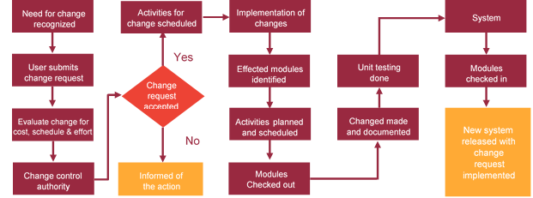

# Miscellaneous

## Acceptance Criteria

* UAT sign off should happen within 14 Days from the release of the application/ Phase and the acceptance confirmation needs to be mailed to Verbat failing which Verbat will consider the project as approved by the client.
* Any comments or reason for rejection need to be documented and the same needs to be sent as an email from the official mail id of client to Verbat.

## General Terms and Conditions

* All the projects activities will be carried out from our off-shore development center in India
* The scope of the project is to develop the Application as detailed in the scope of the project and mentioned in this proposal. Any changes or additions will have to go through change management.
* This proposal and all technical/ functional specifications have been derived or concluded from the data shared via email / information's transferred during the initial requirement analysis meetings and conversations. Verbat reserves the right to amend the terms of this proposal, should the SOW terms, functional features and functionalities change during the course of the project
* Application will be best viewed only in the environment mentioned in this document
* All the documentation will be provided in English.
* Third party components may be used to develop this application.
* All Source Code and other project artefacts would adhere to the Verbat document templates and internal coding standards
* Client shall provide the respective enterprise apple store and Google play store accounts for development and production
* Acceptance criteria shall be based on the clauses which were mutually discussed between Verbat and client at the Requirement Analysis phase and the same will be documented and approved by both parties through official emails
* In case Client requires any extension of the proposed acceptance schedule, the associated effort and cost of such extension can be mutually reviewed.
* For any circumstances if project needs to be put on Hold / Stop it requires minimum request notice period of 2 weeks along with duration for which request will be addressed by management and final decision on the request will be based on that
* If deployment is done in client’s server, Verbat cannot be held responsible for any performance issues arising due to hardware malfunctions.
* Source code will only be delivered or uploaded on the Production Server once the due payments are made.

## Assumptions and Dependencies

* Detailed system study is required before the start of the project.
* During the requirement gathering phase, authorized personnel from the Client’s side is expected to be available for discussion and finalizing the HLD (High Level Design), before development commences.
* Type of reports and formats, if under the scope of the project, needs to be specified by Client before project sign off.
* Workflows if under the scope of the project, need to be specified/ confirmed by client before project signoff.
* All queries regarding the client requirement and any queries which may hinder the project advancement at any stage should be answered by the client within 24 hours from the time of initiation, failing which the time delay will get added to the actual effort which was estimated.
* Verbat assumes that all sign-offs from Client will be provided within agreed and specified timeframe.
* Client will provide all the necessary contents, both text and image, before starting the project in the format suggested by Verbat (if any).
* The client should provide the relevant information and data well in time for the execution of a related activity. Non- availability of this information or data may lead to an interruption of work which may result in a delay in delivery as well as additional costs to the client.

## Source Code & Intellectual Property Rights

* Upon completion of the Project and 100% completion of the payment, client will have access to the source code except for propriety codes, developer tools and third party application etc.
* The solution offered will be the intellectual property of the client and will be made available to the client on an “unlimited license” basis.
* Modifications by third party/person: No person or organization, other than Verbat or any person authorized by Verbat in writing, has any permission to modify/change the software Solution to be eligible to get continued support from Verbat as per the support terms defined under this document.
* Liabilities/Damages: Verbat accepts no liability or damages of any kind arising out of use or non-use of the software delivered. The responsibility of testing of software lies with Client.

## Maintenance & Support

* Maintenance contracts by default are supported as per the basic SLA terms.
* **AMC with Basic SLA is charged at 20 % of the total project value**. Additional Effort/change management request will be added towards Total Value of the Project to determine the AMC value.
* Maintenance support is limited to providing application support for ensuring the consistency of the look-and-feel, bug fixes and user issues i.e. maintenance and support of the existing features of the application.
* Support does not in any way cover providing technical or other support to the end users. The maintenance agreement does not include functionality changes or feature additions which are handled as change requests which will be charged AED 1200 per man day. AMC does not include server support, maintenance and application deployment.
* AMC charges will cover Off-Site Support and Debugging. Support includes E-mail, Telephone and Chat unless explicitly specified. In the event, the application is hosted with the client; necessary remote desktop connectivity should be provided for carrying out maintenance activity.
* Gap in AMC - In case if the client does not opt an AMC for a year and want to renew it after that period, 50% of the AMC amount for the year for which AMC is not taken will also be payable if the client wishes to renew the AMC contract.
* Note:
  + Please note that the AMC support shall start only after all the necessary sign-offs (AMC Document) to this effect have been given.
  + It is not mandatory that the client should opt for an AMC. The client will still be supported on an ad-hoc basis on an agreed man-day rate.
  + AMC Payment Terms: 100% to be paid as advance.

## Service Level Agreement

|  |  |  |  |  |
| --- | --- | --- | --- | --- |
| **Key** | **Max Response Time** | | **Max Resolution Time** | **Target** |
| Basic | 1  working day | 3 working days | | Request / incident / problem tickets |
| Advanced | 5 Business Hours | 12 Business Hours | | Request / incident / problem tickets |
| Priority | 3 Business Hours | 5 Business Hours | | Request / incident / problem tickets |

Note:-

* We provide Basic SLA as standard with AMC while Advanced and Priority SLAs attract additional charges.
* Time zone applicable as per India time zones (3:30 AM GMT to 12:30 PM GMT- Monday to Friday).

# Our Clients

**UAE University**

Education

Transportation

**Canada Cartage**

Construction

Services

Finance

We look forward to hearing from you soon and hope that you will give us the privilege to work with you in meeting your business goals. Thank you.

Thank You



©   
1999 - 2017. All Rights Reserved   
Verbanet Technologies LLC  
www.verbat.com